PRE-OP: Pred-Moxi-Brom Medication Instructions
Surgery Date: ______/_______/_______ RIGHT EYE Surgery Date: ______/_______/_______ LEFT EYE
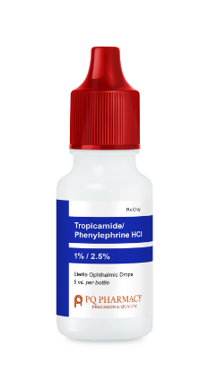
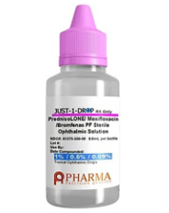
1 Day BEFORE Surgery MORNING OF Surgery
1 drop 3 times a day 1st 45 minutes before leaving home
Morning / Afternoon / Evening 2nd 15 minutes after the 1st drop
3rd 15 minutes after the 2nd drop

Pre-op Instructions
- The surgery center will notify you a week before surgery of your arrival time.
- NO FOOD after midnight the night prior to your surgery. This includes gum, candy, and mints. Surgery will be cancelled or postponed if this is not strictly adhered to.
- Take your heart, blood pressure, Parkinson’s, respiratory, epilepsy and reflux medications, unless instructed not to by your doctor
- You must arrange for a driver, at least 18 years of age, to STAY at the surgery center during your procedure and then drive you home afterwards.
- You are NOT allowed to drive yourself home.

